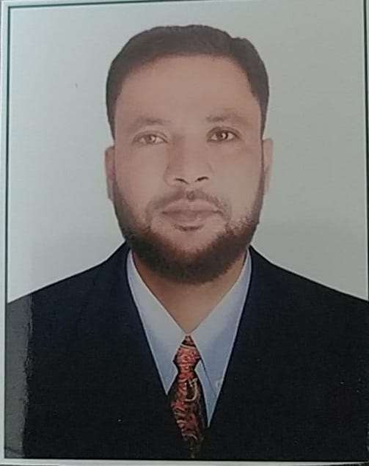

Shaikh Abdul Quadier
Contact: 9890094040 abdulquadieraq@gmail.com
Address: H NO 2-10-119/8 Arfat Colony Kala Darwaza near Haj House Aurangabad.431001.
CAREER OBJECTIVE

A challenging career, which will provide opportunity for continuous growth and learning with a dynamic organization which values individual contribution.
SUMMARY
More than 15 years of experience and proven ability to design implement and analyses, computer and Network infrastructure based on company requirement. Excellent technical skill involving installation, Maintenance and troubleshoots.
CERTIFICATION COURSE
- (MCSE) Microsoft certified system engineer with absolute practice on installation, implementation, troubleshooting and maintenance of small, medium sized networks in person and on remote administration.

CAREER HIGHLIGHTS

Technical Support Engineer
benex Communication, Aurangabad] | [January 2023] – Till Date
- Provide on-site and remote support to end-users for hardware, software, and networking issues.
- Troubleshoot and resolve technical issues related to desktops, laptops, mobile devices, and peripherals.
- Perform regular maintenance of systems and software updates for users.
- Configure Firewalls, Wireless Access Points Device connections.
- Assist in hardware and software installations, upgrades, and migrations.
- Train users on basic IT functionalities and best practices.

Aforeserver.com Ltd
Server Engineer
MAY-2014 to Dec-2014
IT ZONE
Technical Support Engineer
Mar-2012 to Dec-2013
MAINFRAME COMPUTERS PVT LTD
Desktop Support Engineer
June 2004 to Dec 2011

Waluj Hospital Aurangabad [I.T zone Multiservice]
January-2017 to December-2020

- Installing and Configuring Windows Server 2016, Active Directory Services.
- Configuration of the Server Hardware’s, Configuration of RAID in Tower and Blade Server’s
- Solving the regular upcoming Server Hardware issues.
- Managing and Administrating all user domains and accounts

ICON computers and Multi service
Senior Desktop and Network Support Engineer [April-2015 to July 2016]

- Windows mail, Microsoft Outlook.
- Configuring Routers
- Installation of Structure Cabling and Maintenance of patch Panel.
- Installation and configuration of IP CCTV systems and associated Access Control Systems.
- Evaluate signal quality and performance with computers, networks and software.
- Configuration of CCTV systems.

- Assembling Computers. Install and maintain equipment and software
- Networking, LAN & WAN trouble shooting. Network Auditing, Knowledge of configuration and maintenance.
- Connecting printers in network with the desktops & laptops.

- Installation of Desktop and Servers.(HP)
- Configuration of the Server Hardware’s, Configuration of RAID in Tower and Blade Server’s
- Solving the regular upcoming Server Hardware issues.

- Assembling computers.
- Connecting the printers with the desktops & laptops.
- Configuring the Network
- Installing and maintaining hardware and computer peripherals
- Installing and upgrading operating systems and software.
- Troubleshooting network and connection issues.
- Solving the regular upcoming issues.
- Installing and upgrading operating systems and software.
- Troubleshooting network and connection issues.
- Configuring Basic Routers
- Support daily technical support activities for desktop, Laptop, data, and server management
- Providing basic training on computer operation and management.
EDUCATIONAL DETAILS
- MBA: Institute for Integrated Learning in Management. Sikkim University
- Bachelor of Commerce: Babasaheb Ambedker Maharatwada University.
SKILLS
- Assembling computer, Laptop and Server, Troubleshooting.
- Configuration of the Server Hardware’s, Configuration of RAID in Tower and Blade Server’s
- Installing and Configuring Windows Server 2016, Active Directory Services.
- Managing and Administrating all user domains and accounts.
- Networking, LAN & WAN trouble shooting. Network Auditing, Knowledge of configuration and maintenance.
- DHCP (Dynamic host configuration protocol)
- Windows mail, Microsoft Outlook,
- Installation of Structure Cabling
- Installation and configuration of IP CCTV systems and associated Access Control Systems.
- Evaluate signal quality and performance with computers, networks and software.
- Configuration of CCTV systems.
- Configuring Routers and Switch Configuration.
PERSONAL INFORMATION
Name: Shaikh Abdul Quadier

Date of Birth: 3rd -Oct-1984

Nationality: Indian

Marital status: Married

Reference: Available upon request

